Configuring the JSON RPC API (Curl Command)

* Confirm that your Private Network is running
  + Use this command below to prove the number of validators running in your local windows machine (For Mac)

curl -X POST --data '{"jsonrpc":"2.0","method":"ibft_getValidatorsByBlockNumber","params":["latest"], "id":1}' localhost:8545

* + Use this command below to prove the number of validators running in your local windows machine (For Windows)

curl -X POST --data "{\"jsonrpc\":\"2.0\",\"method\":\"ibft_getValidatorsByBlockNumber\",\"params\":[\"latest\"], \"id\":1}" localhost:8545

* Confirm that your Private Network is running on external devices
  + Download Ngrok (an application which tunnels your local host to a public dns address
    - Visit <https://ngrok.com/> and download the binary distribution
    - Open your command prompt and cd into the <ngrok-version> path from the ngrok folder download

C:\WINDOWS\system32>cd C:\Users\Admin\Downloads\ngrok-v3-stable-windows-amd64

* + - Type ngrok http <port-number> which in our case would be 8545

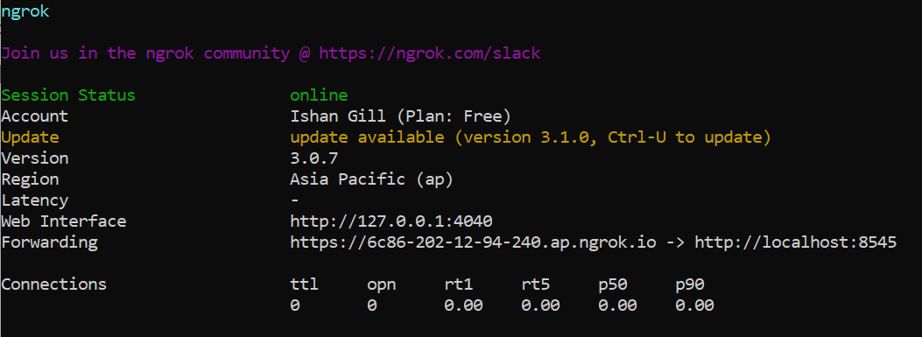

* + Test the ngrok dns address with an external device
    - Type the following command on another computer/device or on a linux shell (Ubuntu)

curl -X POST --data "{\"jsonrpc\":\"2.0\",\"method\":\"ibft_getValidatorsByBlockNumber\",\"params\":[\"latest\"], \"id\":1}" https://6c86-202-12-94-240.ap.ngrok.io

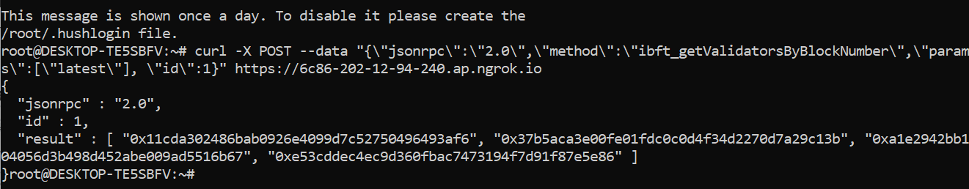

* Add an Additional Validator
  + Create a working directory and a data directory for the new node that needs to be added (mkdir -p Node-5/data)

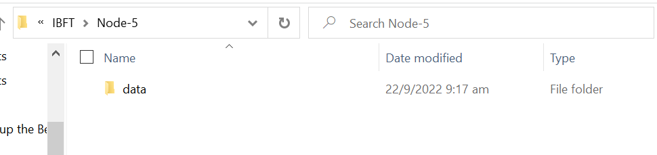

* + Run Node 5

C:\Users\Admin\Documents\GitHub\IBFT\Node-5>besu **--data-path**=data **--genesis-file**=..\genesis.json **--bootnodes**=enode://a32b7b959c0acc4fda78814f1261ab964b535a7e63f25f9fd149b391a016297c7f8b200b9e8a90790904ac0e68ff9c31c7fae63dca866a2e4080a314c7bebe86@127.0.0.1:30303 **--p2p-port**=30307 **--rpc-http-host**=0.0.0.0 --rpc-http-enabled **--rpc-http-api**=ETH,NET,IBFT **--host-allowlist**="*" **--rpc-http-cors-origins**="all" **--rpc-http-port**=8549 **--rpc-ws-enabled**=true **--rpc-ws-host**=0.0.0.0 **--rpc-ws-port**=9549

